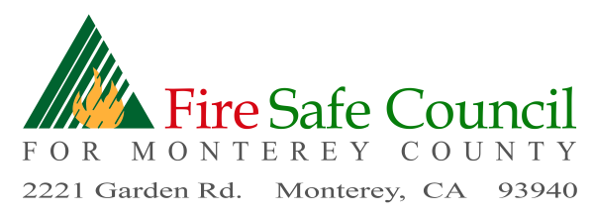
FSCMC – Board Meeting – April 25, 2024, 9:30 – 12:00 noon
In Person – CAL FIRE Expanded Dispatch, 2221 Garden Road
VIA ZOOM - Join Zoom Meeting FSCMC is inviting you to a scheduled Zoom meeting.
https://us06web.zoom.us/j/83107173210
Meeting ID: 831 0717 3210 One tap mobile +16694449171 ,83107173210# US

Richard Bates, President  Firewise USA Coordinator | Pam Peck , Treasurer,  Grants Committee | Mike Caplin, Legislative Committee
Jamie Tuitelle-Lewis, Vice President RCD | Lonni Trykowski  RTG Firewise | Michael Waxer, Legislative Committee  Tehama, CRWC
 | ADVISORS
Sam Balesteri - EMS | Scott Carlton, PG&E | Glenn Church, Royal Oaks
Scott Hanham – President, CFPD | Rayner Marx, Big Sur FAC | Bob Vitale, Spanish Bit, Aromas
 | Wanda Vollmer, POMP

9:30 FSCMC Board Member Meeting - Call to Order- Roll Call-BOD & Advisors
9:35 Administrative
- Board Vote – Secretary, Alecia Hull, Sotheby’s International Realty
- Additions to / Approval of Agenda
- Review and Board Approval of March 2024 Minutes
- Review and Approval of Treasurer's Report, April 2024
- Request for approval of Wildfire Defense Mesh invoice,
- Request for approval of funding for Firewise group (Boranda-Garzas) Template and Expenses
9:45 Executive Committee / Finance Committee
- Report on meeting of Executive/Finance Committees to:
  - Review of Strategic Plan – 2024 – Board Comments
  - Review of Proposed Budget – 2024

10:00- 12:00 FSCMC Open Board Meeting

10:00 –10:15 Introductions

Elise Weiland, Executive Director, Carmel River Watershed Conservancy

10:15 – 11:45 Open Disucssion Firewise program – Assessment/Development
- Wildfire Preparedness Day – Monterey Regional Fire District, Firewise Group & FSCMC
- Raffle for Wildfire Defense Mesh
- Firewise USA Update – - Monterey Bay Firewise Partners
- Firewise Regional areas ? (Reps from NoMoCo – Joanne Helwig, Aromas ?, Hwy 68 ?, Carmel Valley ?, Big Sur – Rayner Marx, Monterey Fire ?)
- Firewise funding program
- CAL FIRE Defensible Space Assessment program – 20 participants
- Other?
11:45 Programs / Grants Committee
- Grant Dashboard
- CWPP Update, moving forward & CWPP Toolkit
- PG&E 2024 Grant Opportunity
- County Coordinator Program – Status Update
- Proposed search funding for Project Director – Status Update
- Carmel Valley Shaded Fuelbreak – Jamie
- CA Coastal Conservancy Grant – Jamie
11:45 – 12:00 Legislative Committee
- Monterey County General Plan Safety Plan Update
- Land Use Plan update –Coastal Plan update, 5/29, 5-8 pm
New Business:
Old Business:
12:00 Adjournment
Next Meeting: Thursday, May 30, 2024, In person at CAL FIRE Dispatch & Hybrid via Zoom

