DRAFT Agenda - Thursday, April 28, 2022 @ 9:30 am-12:00 noon
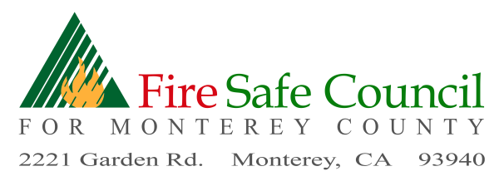

9:30 FSCMC Board Member Meeting - Call to Order- Roll Call-BOD & Advisors

9:35 Administrative
- Approval / Addition to Agenda
- Review and Board Approval of Minutes – March 31, 2022
- Monthly Board Meeting -May 26, 2022 and Committee Meetings-May 12, 2022 :830-9:30

9:45 Executive Committee
- Paul Chetirkin, MCC Project Manager Introduction
- Work Group MCC Grant Project Management & Response to CAL FIRE
- Financial Reports Pam

10:00 FSCMC Open Board Meeting

President’s Report

10:10 Outreach and Education Committee
- Firewise USA Updates Richard-May 5, Thursday 6:00-7:30 Zoom
- Social Media Coordinator-Tessa-Santa Lucia Preserve, increase database
- Marci Bracco-terminate FB posts
- Fire Adapted Program Pam
- Wildfire Presentations May 3&4 9-12
- Job Postings website/social media-Mike

10: 25 Funding/Grant Committee

County Coordinator Status (pending) Head Hunter
- Scott Hanham’s proposed funding for communities
- Coastal Commission Grant
- FireAside Monday May 2, 9, 11 after 4 pm

10:40 Legislative Committee
- New laws – AB 2750 Input
- Hazard Mitigation Input

11:00 Public Comment-Introductions

11:45 Old Business
- Ag Pass
- Planting Guide Brochure
- ALERTWildfire sites

11:50 New Business

12:00 Adjournment

Next Meeting will be held via Zoom May 26, 2022

