DRAFT Agenda - Thursday, May 25, 2023 @ 9:30 am-12:00 noon
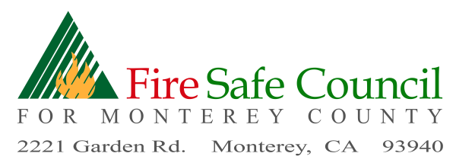

IN PERSON – CAL FIRE Expanded Dispatch, 2221 Garden Road, Monterey
OR - Join Zoom Meeting
https://us06web.zoom.us/j/81589314952
Meeting ID: 815 8931 4952
One tap mobile - +16694449171,,81589314952# US

Richard Bates, VP  Firewise USA Coordinator | Pam Peck , Treasurer,  Grants Committee | Mike Caplin,  Legislative Committee
Jamie Tuitelle- Lewis  RCD | Lonni Trykowski,  RTG Firewise | Michael Waxer, Tehama Carmel River Watershed

Sam Balesteri - EMS | ADVISORS  Glenn Church, Royal Oaks | Scott Hanham – VP Cypress Fire Protection District
 | Rayner Marx, Big Sur Fire Adapted Communtes

9:30 FSCMC Board Member Meeting - Call to Order- Roll Call-BOD & Advisors

9:35 Administrative
- Additions to / Approval of Agenda
- Review and Board Approval of Minutes – April 27, 2023
- Review and Approval of Treasurer's Report
- Schedule Monthly Board Meeting –June 29 2023, (Place TBD)

9:45 Executive Committee
- Board/Advisor Recruitment Update
- Introduce Wanda Vollmer – Peace of Mind Preparedness - Advisor

10:00 FSCMC Open Board Meeting Public Comment (3 min. limit)
Participant Introductions / Reports & Announcements -
Expanding FSCMC's efforts to foster community participation
- Firewise USA Communities
- MCRFD - (Chief Sargenti, Kevin Kamnikar, Scott Anderson, Matt Lumadue)
- Monterey Peninsula Regional Parks (Jake Smith)
- USFS (Pete Harris, Fire Management Officer)
- RCD (Jamie Tuiteli-Lewis - Brandt Bates - projects)
- Fire Adapted Big Sur (Rayner Marx)
- CALFIRE - (Chief Nunez, Matt Stafford, Brice Muenzer)
- BLM (Keegan Guillory)
- MoCo Planning Dept or Office of Emergency Services (Kelsey Scanlon)
- PG&E - (Alexandra Baldwin)
- Carmel River Watershed Conservancy (Abby Beane )
- Santa Lucia Preserve (Emily Aiken)
- UCCE, Fire Advisor (Barb Satink Wolfson)

10:45 Programs Committee – Richard Bates
- Firewise USA Updates - Open discussion for FW Communities - 5 min each
- Firewise Events & Projects
- Concept – Guest Speakers
- MBFWP – next meeting
- Mapping – Firewise communites , collaboration with CFSC GIS
- Insurance regulation updates

11:30 Grants Committee-Pam Peck
- Coordinator Grant – Anthony Anderson,
- CC Grant – Wildfire Preparedness Day Event – Kim Ann Lane
- CAFSC Grant opportunity - Defensible Space Assistance Grant
- MCC Funding issue
- CVFB – Workshops scheduling (Jamie Update)
- Coastal Conservancy Grant – (Jamie Update)
- Mapping Grant for Monterey & San Benito Counties (Jamie)
- CERV Grant and Video

11:40 Legislative Committee-Michael Waxer/Mike Caplin

11:45 Old Business

11:55 New Business

12:00 Adjournment Next Meeting will be held on June 29, 2023 Location TBD

